**Fluorescence lifetime imaging detects long-lifetime signal associated with reduced pyocyanin at the surface of *Pseudomonas aeruginosa* biofilms and in cross-feeding conditions**

Tara Gallagher*1, Simon William Leemans*2, Alexander Dvornikov2, Kumar Perinbam3, Joshua Fong1, Christina Kim1, Joseph Kapcia1, Miki Kagawa1, Adam Grosvirt-Dramen4, Allon Hochbaum4, Michelle Digman2, Enrico Gratton2, Albert Siryaporn3, Katrine Whiteson#1

* T.G. and S.W.L. contributed equally

# Corresponding author: Katrine Whiteson, katrine@uci.edu

1. University of California Irvine Department of Molecular Biology and Biochemistry

Irvine, CA, US 92697-2525

1. University of California Irvine Department of Biomedical Engineering

Irvine, CA, US 92697-2715

1. University of California Irvine Department of Physics and Astronomy

Irvine, CA, US 92697-4575

1. University of California Irvine, Chemical Engineering and Materials Science; Chemistry

916 Engineering Tower

Irvine, CA, US 92697-2575

Journal: ACS Infectious Disease

**Supporting Information: Supporting Information Available free of charge**

Fluorescent emission spectra of all fluorophores, including fluorophores with emission spectra outside of the FLIM range

Fluorescent spectra and lifetime signal for chemically and electrochemically reduced pyocyanin

Fluorescent intensity signal at the surface vs. bottom of the biofilm and similar lifetime signal for different frame counts

FLIM distributions for *P. aeruginosa* biofilms compared to uninoculated media

FLIM-phasor signal for different bacteria

Comparison of FLIM signal for biofilms with and without a coverslip

Pairwise t-test results for phasor coordinates for different biofilm depths

Pairwise t-test results for phasor coordinates for cross-feeding conditions

**Abstract:**

Understanding bacterial physiology in real-world environments requires non-invasive approaches and is a challenging yet necessary endeavor to effectively treat infectious disease. Bacteria evolve strategies to tolerate chemical gradients associated with infections. The DIVER (Deep Imaging Via Enhanced Recovery) microscope can image auto-fluorescence and fluorescence lifetime throughout highly- scattering samples, enabling the study of naturally-forming chemical gradients throughout intact biofilms. Using the DIVER, a long fluorescent lifetime signal associated with reduced pyocyanin, a molecule for electron cycling in low-oxygen, was detected in low-oxygen conditions – at the surface of *Pseudomonas aeruginosa* biofilms and in the presence offermentation metabolites from *Rothia mucilaginosa,* which co-colonizes infected airways with *P. aeruginosa*. These findings underscore the utility of the DIVER microscope and fluorescent lifetime in non-invasively studying bacterial physiology within complex environments, which could inform on more effective strategies for managing chronic infection.

**Keywords:**

Fluorescence, fluorescence lifetime, biofilm, *Pseudomonas aeruginosa*, pyocyanin, phenazines

To colonize an infection site, bacteria adapt to low-oxygen conditions commonly found at infection sites, such as in wounds and in the Cystic Fibrosis (CF) airways, due to oxygen consumption by host cells and bacterial biofilms (1–4). *Pseudomonas aeruginosa* survives in low-oxygen through anaerobic respiration via denitrification (5, 6) and secreting phenazines (7, 8), which are colorful, electron-recycling molecules that contribute to disease progression (7–12). Low oxygen, along with high cell density (13, 14) and fermentation metabolites (15, 16), promote production of the phenazine pyocyanin. Pyocyanin can be retained in biofilms by *P. aeruginosa*-derived extracellular DNA (17, 18), allowing electron cycling across biofilms. Furthermore, pyocyanin has been linked with increasing *P. aeruginosa* tolerance to antibiotics in low-oxygen environments (19).

Given its role in hypoxic survival and disease, detecting pyocyanin in infections and relevant infection models is of interest. Pyocyanin is a blue-pigmented, non-fluorescent molecule in its oxidized form (12, 20). The reduced form of pyocyanin is fluorescent, with an emission spectra that overlaps with NADH and pyoverdine (21). Hyperspectral imaging can unmix multiple fluorophores (21), though commercial microscopes have limitations in imaging depth-dependent signals. The DIVER (Deep Imaging Via Enhanced Recovery) (22, 23) is a custom-made microscope that measures fluorescent intensity and fluorescent lifetime throughout high-scattering samples.

Fluorescent lifetime refers to the exponential decay of the fluorescent intensity and can be used to identify multiple fluorophores contributing to a signal. Fluorescent lifetime imaging microscopy (FLIM) data can be represented using phasors, a fit-free approach to analyze FLIM data (24). The FLIM-phasor represents longer lifetimes at the origin (G=0, S=0), and shorter lifetimes near the right corner (G=0, S=1). Fluorophores with single exponential decays appear on the “universal circle” of the phasor (for example, the phasor coordinates of six pure fluorescent dyes are depicted in **Fig. 1B**). Samples containing multiple fluorophores will generate a phasor signal within the area formed by connecting the points of the individual fluorophore signals. The signal’s distance from each contributor can be used to calculate relative contributions. For single-measurement imaging approaches (e.g. first-harmonic FLIM), a maximum of two or three species can be unmixed (24, 25). In complex systems with more than three species, the phasor can still be used to track physiological changes, particularly when the fluorophore of interest has a distinct phasor window (26).

**RESULTS & DISCUSSION:**

**Spectral and FLIM characterization of *P. aeruginosa* fluorophores.**

The 2-photon emission spectra of eight fluorophores were characterized with a hyperspectral imaging microscope (740 nM excitation and emission range of 400-690 nm). The fluorophores included ubiquitous metabolites such as coproporphyrin, flavin adenine dinucleotide and nicotinamide adenine dinucleotide, in addition to pyoverdine and phenazines *–* 1-hydroxyphenazine, phenazine-1-carboxylic acid, phenazine-1-carboxamide, pyocyanin (**Fig. S1**). Chemically and electrochemically reduced pyocyanin had a peak emission at 520 nm (**Fig. S2, Fig. 1A**). The peak emission at 520 nm differed from a previous study, which found chemically-reduced pyocyanin had a peak at 475 nm, despite using identical reduction methods and similar fluorescent approaches (21).

Based on spectral analyses (**Fig. 1A, S1**), four of the eight fluorophores (NADH, reduced pyocyanin, reduced 1-hydroxy-phenazine, and pyoverdine) can be captured by the FLIM acquisition parameters used in downstream experiments, which included a blue emission filter (400-500 nm). While the spectrum of the pyocyanin precursor, 5-methyl phenazine-1-carboxylic acid, was not measured in this study due to commercial unavailability, previous studies have reported an emission peak at 620 nm (21, 27). The fluorescence of 5-methyl phenazine-1-carboxylic acid would likely contribute minimally to signal detected by the blue emission filter.

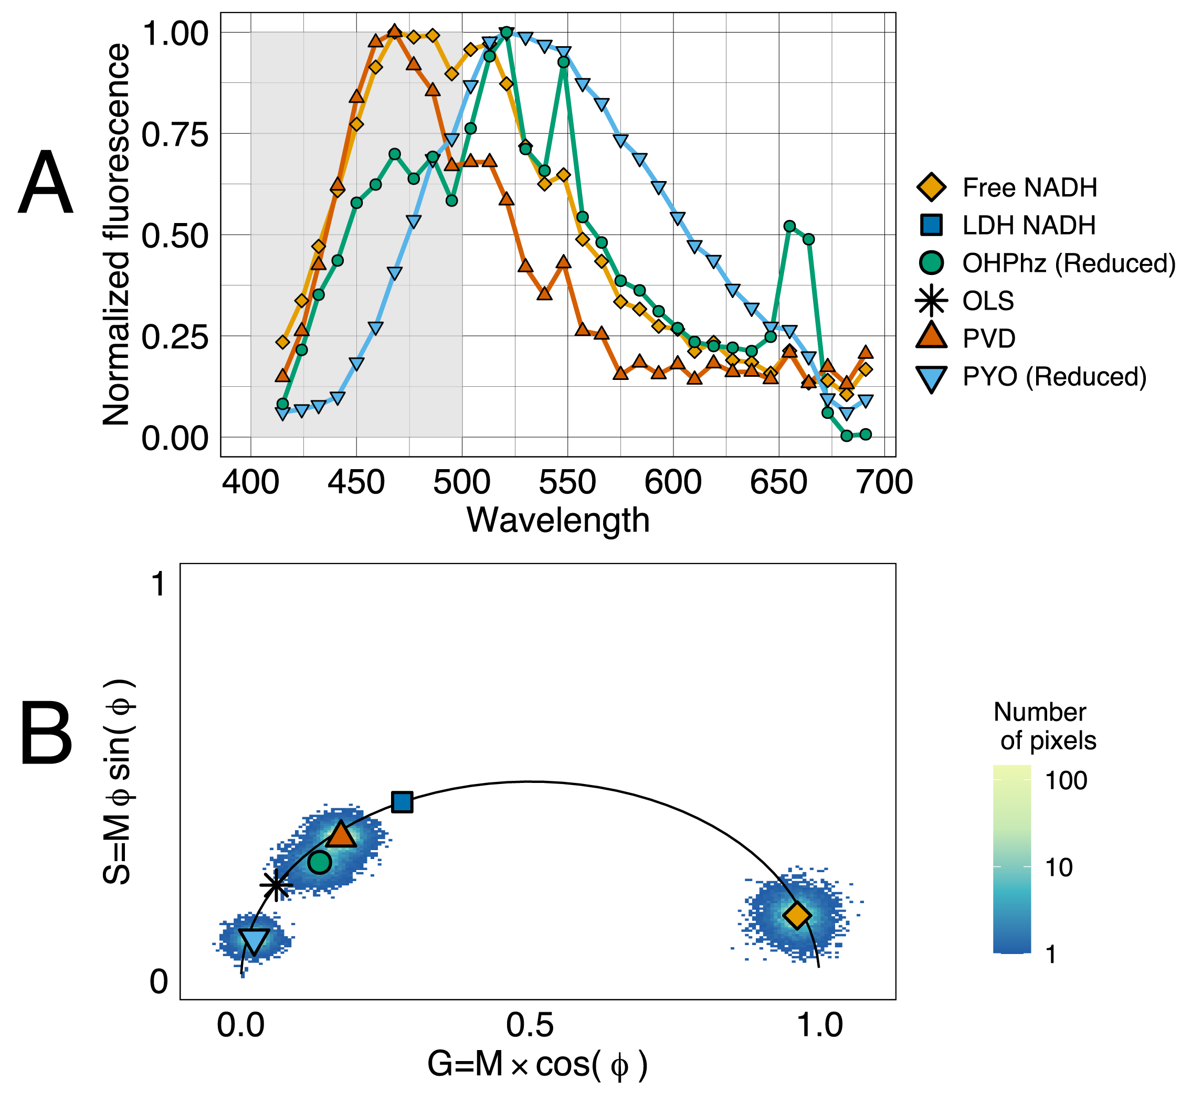

**Figure 1: Fluorescent spectra and lifetime phasor of some of the fluorescent metabolites produced by *P. aeruginosa***(two-photon excitation = 740 nm). (**A**) Fluorescence emission spectra normalized by max peak intensity of fluorophores which emit in the 400-500 nm window (gray-shaded box). (**B**) FLIM-phasor of pure solutions, collected with a Schott BG-39 filter and NADH-targeted emission filter (400-500 nm). Points represent phasor G and S coordinates from a fluorescence lifetime image, colored by the number of pixels. The large shapes represent the mean G and S values for each fluorescent solution. The mean G and S values for LDH NADH and OLS were determined from previously reported fluorescence lifetimes (26, 28). LDH = Lactate Dehydrogenase, OHPhz = 1-hydroxyphenazine (DTT reduced), OLS = Oxidized Lipid Signal, PVD = pyoverdine, PYO = pyocyanin (TCEP reduced).

The FLIM-phasor positions of solutions of free NADH, reduced 1-hydroxyphenazine, reduced pyocyanin, and pyoverdine are on the universal circle, suggesting the signals originate from a single exponential decay (**Fig. 1B**). For reference, also depicted are the previously-reported phasor coordinates of lactate dehydrogenase (LDH) bound NADH (29) and an oxidized lipid signal (OLS) (26). Notably, reduced pyocyanin had a long lifetime signal (mean G= 0.02, S= 0.1; lifetime >10 ns) with a distinct phasor position (**Fig. 1B**).

The emission spectra and lifetime of pyocyanin shifted with increasing TCEP concentrations, indicative of a longer fluorescence lifetime as the solution was further reduced (**Fig. S2**). Pyocyanin was nearly on the FLIM universal circle when mixed with a 1:1 ratio of TCEP in an anaerobic chamber (**Fig. 1B, S2B**).

**Longer fluorescence lifetimes at the surface of *P. aeruginosa* biofilms when limiting oxygen exposure**

To recapitulate slower bacterial growth observed in infections (30, 31), colony biofilms were grown for 72h in soft agar. The radial center of the colony, or inoculation point, was imaged axially using the DIVER microscope to capture signals associated with biofilm depth in the oldest population (22, 23). Laser power was increased with imaging depth to compensate for signal attenuation (**Fig. S3A-B**). Prolonged laser exposure did not significantly affect fluorescence lifetime signals, as the phasor coordinates were similar when comparing the first frame to all frames for a given sample (**Fig. S3C**), where a higher number of acquired frames had lower noise (**Fig. S3D**).

Two strainswere cultured: wildtype (WT) and a phenazine double mutant *P. aeruginosa* PA14 *∆phzA1-G1*/ *∆phzA2-G2* (∆*phz*). The phasor position of *P. aeruginosa* cultures was distinct from uninoculated media, except for ∆*phz* strains grown in ASM, likely due to high amounts of NADH in ASM (**Fig. S4, Fig. 2B-C**). The FLIM-phasor signal of the WT strains shifted with biofilm depth in both ASM and M9 succinate, as demonstrated by a shift in G and S distributions (**Fig. 3A-B).** The mean G and S values also had a depth-dependent shift for the WT strain **(Fig. 3C; Table S1**). Specifically, WT PA14 had significantly different phasor G and S values at the surface of the biofilm compared to measurements at deeper layers in ASM and M9 succinate (t-test, FDR < 0.05; **Table S1**). The depth-dependent lifetime shift was not observed in the *∆phz* cultures (**Fig. 3, Table S1**). The surface of the WT biofilm was dominated by a longer lifetime species. The long fluorescent lifetime signal associated with the WT *P. aeruginosa* cultureswas *not* observed in other microbial genera (**Fig. S5**) and has been reported in previous FLIM studies (32, 33). Examples of fluorescent intensity images (**Fig. 3A**), with the FLIM-phasor signal color-mapped on top of the image (**Fig. 3B-C**) suggest that secreted molecules contributed to the signal both inside and outside of the cell clusters.

Given that other phenazines emit low fluorescent signal within the emission filter range and reduced 1-hydroxyphenazine has a short fluorescence lifetime distinct from reduced pyocyanin (**Fig. 1, S1**), reduced pyocyanin is likely producing the long lifetime signal found at the surface of WT *P. aeruginosa* biofilms (**Fig. 2, 3**).

We initially hypothesizedthere would be higher levels of reduced pyocyanin deeper in the biofilm (7–9) due to less oxygen exposure. However, the long lifetime signal associated with reduced pyocyanin was prominent at the biofilm surface. The reduced pyocyanin signal was prominent when the surface of biofilms had limited oxygen exposure from the addition of a coverslip (**Fig. S6**), and there was high density of *P. aeruginosa* growth at the biofilm surface (**Fig. 2, 3**). This model agrees with previous observations that population density controls phenazine biosynthesis (13, 14) and oxygen is required for pyocyanin biosynthesis (34). Although it may seem counterintuitive, pyocyanin has the highest affinity for oxygen out of other studied phenazines (10), and in locally anoxic conditions, *P. aeruginosa* couples pyocyanin reduction with oxidation of glucose and pyruvate (35). Reduced pyocyanin is secreted and oxidized extracellularly (8, 9), and a portion of pyocyanin is retained in the biofilms when bound to extracellular DNA to enable electron cycling across biofilms (17, 18).

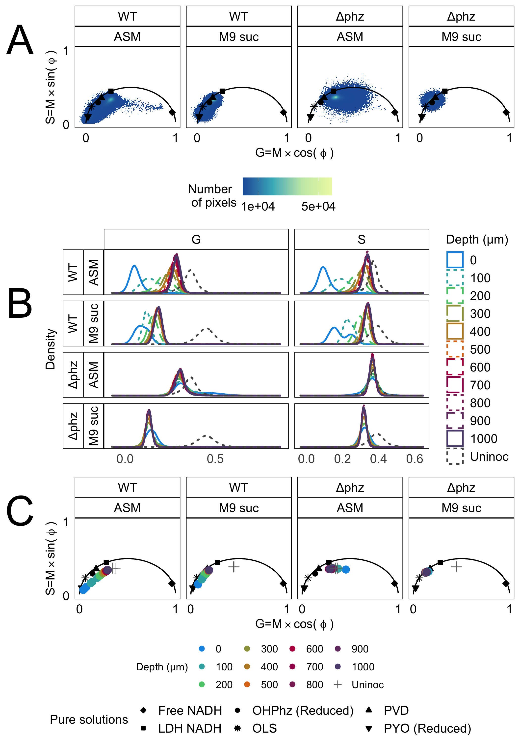

**Figure 2: Fluorescence lifetime at different depths of *P. aeruginosa* PA14 biofilms.** (**A**) Fluorescence lifetime phasor of *P. aeruginosa* PA14 WT and *∆phz* strains grown in ASM or M9 succinate soft agar. Biofilms were imaged at 100 µM intervals from the biofilm surface (0 µm) to 1000 µm deep, with three replicates per strain and media type (132 images total). The fluorescence lifetime phasor of each image was plotted as G and S values, with the color indicating pixel quantity. Mean G and S values of fluorescent solutions from Figure 1 are displayed as black shapes. (**B**) The one-dimensional distributions of phasor G and S values showed a significant leftward shift in the WT biofilms compared to *∆phz* (Wilcoxon rank sum test, p-value < 0.05). Line type and color are indicative of biofilm depth. The gray dotted line is the uninoculated M9 succinate or ASM media (2 images). (**C**) Mean G and S values for each image, colored by biofilm depth. The gray crosses represent mean G and S values for uninoculated ASM and M9 succinate. The mean G and S values for WT PA14 were significantly different at the biofilm surface than at other measured depths (200-1000 µM for M9 succinate and 100-1000 µM for ASM; **Table S1**). *∆phz* = *P. aeruginosa* PA14 *∆phzA1-G1/∆phzA2-G2*; LDH = Lactate dehydrogenase, OHPhz = 1-hydroxyphenazine, OLS = Oxidized Lipid Signal, PVD = pyoverdine, PYO = pyocyanin, ASM = artificial sputum medium, suc = succinate.

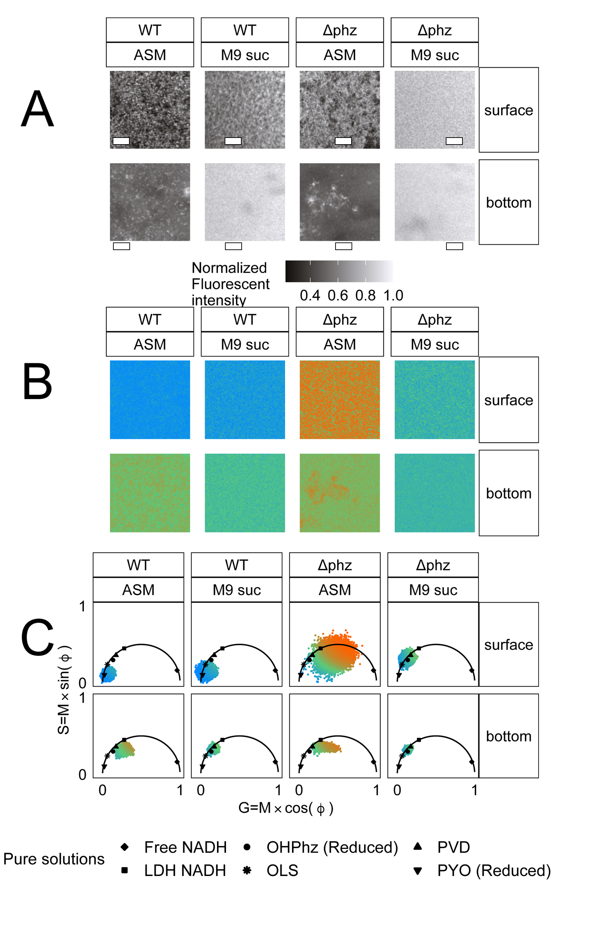

**Figure 3: Fluorescence intensity and lifetime images at the surface and 300-1000 µM deep into *P. aeruginosa* PA14 biofilms.** (**A**) Auto-fluorescent intensity images of *P. aeruginosa* PA14 WT and *∆phz* strains grown in ASM or M9 succinate soft agar. Scale bar = 20 µm. (**B**) Fluorescence lifetime images at the surface and 300-1000 µM deep into *P. aeruginosa* biofilms. In (**B**), each pixel in the image is colored based on phasor position from (**C**). For reference, mean G and S values of pure fluorescent solutions from Figure 2 are displayed as black shapes (**C**). The same color map was used for all lifetime images, where blue is indicative of a longer lifetime near the origin of the phasor. Lactate Dehydrogenase, OHPhz = 1-hydroxyphenazine, OLS = Oxidized Lipid Signal, PVD = pyoverdine, PYO = pyocyanin, ASM = artificial sputum medium, suc = succinate*, ∆phz* = *P. aeruginosa* PA14 *∆phzA1-G1/∆phzA2-G2*.

***P. aeruginosa* fluorescence lifetime shifts in the presence of *Rothia* metabolites**

Although incapable of anaerobic fermentation, *P. aeruginosa* co-colonizes infection sites with fermenting microbes, including *R. mucilaginosa.* To explore the effect of fermentation metabolites on *P. aeruginosa* FLIM signal, *P. aeruginosa* PaFLR01 was grown with supernatant from *Rothia mucilaginosa (*M9 suc + sup), in M9 media alone (M9 suc), or in ASM (the background media of the *Rothia* supernatant) (**Fig. 4**). The S distribution of *P. aeruginosa* grown in M9 suc + sup was significantly shifted to the left towards reduced pyocyanin relative to the ASM and M9 suc controls (**Fig. 4**), and the mean phasor values of M9 suc + sup relative to ASM were significant or nearly significant (G coordinate FDR < 0.05; S coordinate FDR = 0.1; **Table S2**). Previous studies showed that *P. aeruginosa* metabolizes pyruvate and lactate generated by *R. mucilaginosa* in the supernatant (36). The presence of fermentation metabolites may be used as an indicator of low oxygen, driving production of pyocyanin before oxygen depletion.

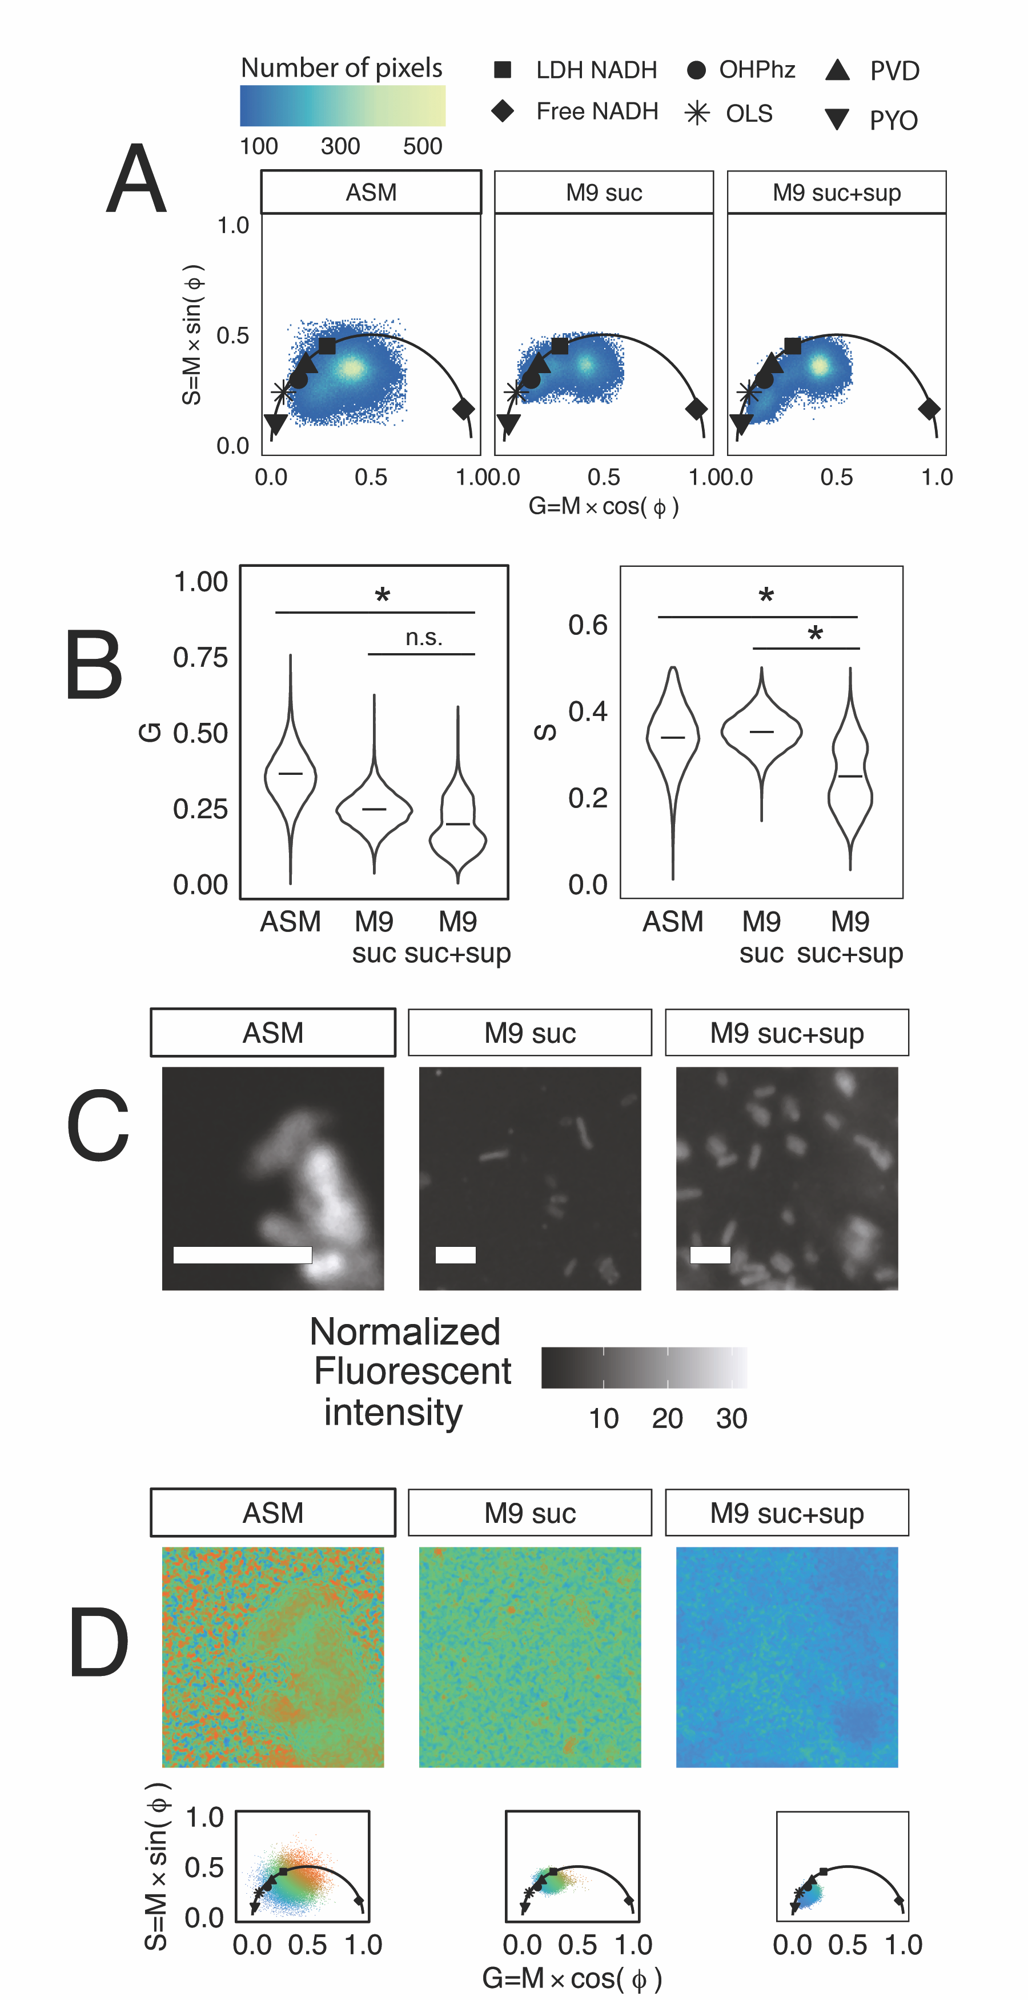 ­­

**Figure 4: *P. aeruginosa* PaFLR01** **fluorescence lifetime shifts when cross-fed *Rothia* supernatant.** (**A**) Fluorescence lifetime phasor of PaFLR01 grown in three media types under hypoxic conditions. Scatter plot points are G and S coordinates of pixels from fluorescence lifetime images of PaFLR01 grown in hypoxic ASM (14 images), M9 suc (8 images), or M9 suc + sup (7 images). Mean G and S values of pure fluorescent solutions are displayed on the universal circle as black shapes. The two-dimensional G and S distributions were significantly different for each pairwise comparison (ASM vs. M9 suc, ASM vs. M9 suc+sup, M9 suc vs. M9 suc+sup; Fasano-Francheschini Test, p-value < 0.05). (**B**) The one-dimensional distributions of G and S for each media condition, the middle bar is the mean G and S of all images. M9 suc + sup S distributions were significantly lower than the M9 suc and ASM conditions (p-value < 0.05, **Table S2**). (**C**) Examples of fluorescent intensity images from the cross-feeding experiment. Scale bar = 3 µm. (**D**) The fluorescence lifetime image (top) from three samples, colored by phasor position (bottom). Blue is indicative of a longer lifetime near the origin of the phasor. LDH = Lactate Dehydrogenase, OHPhz = 1-hydroxyphenazine, OLS = Oxidized Lipid Signal, PVD = pyoverdine, PYO = pyocyanin, ASM = artificial sputum medium, suc = succinate, sup = supernatant from *Rothia mucilaginosa*.

**Conclusion.**

To our knowledge, this is the first study to measuremetabolic signal throughout an intact *P. aeruginosa* biofilm. We detected a long fluorescent lifetime signal associated with reduced pyocyanin at the surface of intact biofilms and in the presence of fermentation metabolites. Given the significance of pyocyanin in disease progression and *P. aeruginosa* physiology, the DIVER FLIM approach shows promise as a tool to advance understanding of infections and treatment strategies in infection-relevant models.

**Limitations and future directions.**

Due to the large number of fluorescent species produced by *P. aeruginosa,* detection of every fluorophore was not feasible. In this study, any fluorescent (26)Due to the large number of detected fluorophores, calculating the relative abundance of each species was not possible. However, combining hyperspectral approaches with FLIM shows promise for unmixing fluorescence signals in complex systems (37)

**METHODS**

**Chemicals and bacterial media.**

Ten millimolar stocks of pyocyanin (Sigma-Aldrich P0046) and 1-hydroxyphenazine (OHPhz) (Fisher H0289100MG) were dissolved in 20% ethanol and methanol, respectively. Phenazine-1-carboxamide (PCN) (Sigma-Aldrich AMBH2D6F8130) and phenazine-1-carboxylic acid (PCA) (Fisher 2538-68-3) were dissolved in chloroform to 4.5 mM. Dissolved phenazine stocks were stored at -20˚C.

Artificial sputum and M9 minimal media with 40 mM succinate soft agar in large petri dishes (150x15 mm) were used to grow *P. aeruginosa* biofilms. Both media recipes were modified from Gao et al. (36) to include 0.28% final agar concentration.

**Bacterial strains and growth.**

*P. aeruginosa* PA14 and the phenazine knockout *phzA1-G1/A2-G2* were obtained from Dianne Newman (California Institute of Technology). For biofilm imaging, the bacteria were grown overnight on Todd-Hewitt agar, and individual colonies were inoculated into the center of the artificial sputum (ASM) or M9 succinate soft agar plates (36). The biofilms were grown in an aerobic incubator at 37˚C for 3 days.

For the cross-feeding experiment, Rothia mucilaginosa RmFLR01(15, 36) was grown in liquid (ASM) for 48h. *Rothia*-derived supernatant was then filtered and cross-fed to a cystic fibrosis isolate, *P. aeruginosa* FLR01, in liquid M9 succinate for 72h in hypoxic conditions (2% oxygen). For a control, *P. aeruginosa* FLR01 was also grown in liquid M9 succinate media or ASM alone. After the 72h incubation, 5 µL of the *P. aeruginosa* FLR01 culture was transferred to a slide and mixed with 5 µL of 1% pre-warmed agar, heated to approximately 55°C in a hypoxic chamber (2% oxygen). To maintain a hypoxic environment the coverslip was then sealed onto the slide with nail polish. The slide was removed from the chamber and imaged within 30 minutes.

**Chemical and electrochemical reduction of phenazines**

Prior to reduction, dissolved phenazine stocks were moved from the -20˚C to a Coy Anaerobic Chamber (0% oxygen).

For chemical reduction of pyocyanin, 75 to 600 µM stocks of pyocyanin were diluted in 1X MOPS buffer with TCEP concentrations ranging from 0.1 mM to 125 mM (pH 7).

For electrochemical reduction, a fresh stock of 821 µM of pyocyanin was prepared in ammonium acetate 0.1M KCl MOPS buffer and electrochemically reduced following Wang and Newman (10). The electrochemical cell consisted of a glassy carbon working electrode, platinum wire counter electrode, and Ag/AgCl reference electrode. The voltage was set to -0.345V, and the reaction proceeded in an anaerobic chamber overnight until the current reached zero.

The three other phenazines only underwent chemical reduction. For 1-hydroxyphenazine, 500 micromolar stocks were diluted in 1XMOPS buffer with pH 7-buffered DTT as the reducing agent. Five hundred micromolar stocks of phenazine-1-carboxamide and phenazine-1-carboxylic acid were diluted in 1x MOPS buffer with 5 mM TCEP.

**Hyperspectral and fluorescence lifetime imaging on Zeiss LSM-880.**

To characterize the emission spectra and fluorescence lifetime of NADH, FAD, pyoverdine, reduced pyocyanin, and reduced 1-hydroxyphenazine, pure solutions were transferred to a clean slide. Reduced pyocyanin and 1-hydroxyphenazine were prepared in a Coy anaerobic chamber and sealed with iSpacers to avoid oxygen exposure (<https://www.sunjinlab.com/>).

WT PA14 and *∆phz* biofilms grown in ASM and M9 succinate soft agar were cut with a sterile razor and placed onto a MATTEK dish (P35G-1.5-14-C) with the biofilm surface facing the coverslip. To compare the impact of oxygen on the spectral and lifetime signal, the biofilm samples were (1) placed in a dish and immediately imaged or (2) were placed in between two coverslips and sealed in the dish with tape for 2h at room temperature.

The pure fluorophore solutions and biofilm surfaces were imaged on an inverted Zeiss LSM-880 with an ISS Spartan3 FLIMbox, BH HPM-100-40-Hybrid detector, and a Spectra Physics MaiTai titanium-sapphire laser. The fluorophores were excited with 2-photon excitation at 740 nm and laser power ranging from 1-10 mW. For hyperspectral imaging, emission ranging from 410-695 nm was collected with 9 nm step resolution over 32 channels. One frame was collected per sample with a pixel dwell time of 4 µs. The spectra were analyzed on Zeiss Zen software, and .lsm files were exported for downstream steps. After collecting the spectra, fluorescence lifetime of the same sample was obtained by switching the light path to the FLIMbox detectors. The sample was excited with the same wavelength and laser power as the spectral images. The emission was filtered with a 495 nm LP dichroic and Semrock 442/46 nm BrightLine single-band bandpass filter (CFW-BP01-Clin-25). The fluorescence lifetime data was acquired using SimFCSv4. -20200515. To obtain enough fluorescence lifetime signal for the downstream analysis, 10-30 frames were collected per sample, with a frame size of 256x256 pixels and pixel dwell time of 32 µs.

**Z-stack fluorescence lifetime of biofilms on the DIVER microscope.**

Intact WT *P. aeruginosa* PA14biofilms were grown in ASM for three days and prepared for z-stack imaging by adding a large coverslip on top of the surface of the biofilm, and then imaged with a 0.8Olympus LUMPLFLN 40XW Objective. Z-stacks were obtained on a custom-made microscope at the Laboratory for Fluorescence Dynamics, the DIVER (Deep Imaging Via Enhanced Recovery) (22, 23x). The DIVER is a Nikon Eclipse TE2000-U microscope equipped with a wide-area 18x18 mm photomultiplier tube (PMT) (Hamamatsu R7600P-300) which enhances photon collection. Samples were excited with 2-photon excitation at 740 nm using a Tsunami Spectra-Physics Ti:Sapphire laser (80 MHz). The emission was filtered with a Schott BG-39 filter and NADH-targeted optical bandpass filter (400-500 nm). Fluorescence lifetime data was collected with SimFCS v4 software. Z-stacks were automatically acquired every 100 µm, from the surface of the biofilm to 1 mm deep, which was the maximum depth at which the FLIM-phasor signal was distinct from uninoculated media for WT cultures. The laser power was increased with an exponential function for deeper sample imaging, with the power ranging from 1-58 mW.

**Fluorescence lifetime analysis and visualization.**

Fluorescent lifetime data analysis was performed in SimFCS v4-20200515 software (38). The pixels in the fluorescent images were median-filtered. Plots and statistical analyses were performed in python and R (<https://github.com/tgallagh/PseudomonasFLIM>).

**REFERENCES**

1. Cowley ES, Kopf SH, LaRiviere A, Ziebis W, Newman DK. 2015. Pediatric cystic fibrosis sputum can be chemically dynamic, anoxic, and extremely reduced due to hydrogen sulfide formation. mBio 6:e00767-15.

2. Worlitzsch D, Tarran R, Ulrich M, Schwab U, Cekici A, Meyer KC, Birrer P, Bellon G, Berger J, Weiss T, Botzenhart K, Yankaskas JR, Randell S, Boucher RC, Döring G. 2002. Effects of reduced mucus oxygen concentration in airway Pseudomonas infections of cystic fibrosis patients. J Clin Invest 109:317–325.

3. Martin LW, Gray AR, Brockway B, Lamont IL. 2023. Pseudomonas aeruginosa is oxygen-deprived during infection in cystic fibrosis lungs, reducing the effectiveness of antibiotics. FEMS Microbiol Lett 370:fnad076.

4. Kolpen M, Hansen CR, Bjarnsholt T, Moser C, Christensen LD, Gennip M van, Ciofu O, Mandsberg L, Kharazmi A, Döring G, Givskov M, Høiby N, Jensen PØ. 2010. Polymorphonuclear leucocytes consume oxygen in sputum from chronic Pseudomonas aeruginosa pneumonia in cystic fibrosis. Thorax 65:57–62.

5. Line L, Alhede M, Kolpen M, Kühl M, Ciofu O, Bjarnsholt T, Moser C, Toyofuku M, Nomura N, Høiby N, Jensen PØ. 2014. Physiological levels of nitrate support anoxic growth by denitrification of Pseudomonas aeruginosa at growth rates reported in cystic fibrosis lungs and sputum. Front Microbiol 5.

6. Palmer KL, Brown SA, Whiteley M. 2007. Membrane-Bound Nitrate Reductase Is Required for Anaerobic Growth in Cystic Fibrosis Sputum. J Bacteriol 189:4449–4455.

7. Price-Whelan A, Dietrich LEP, Newman DK. 2006. Rethinking “secondary” metabolism: physiological roles for phenazine antibiotics. Nat Chem Biol 2:71–78.

8. Glasser NR, Kern SE, Newman DK. Phenazine redox cycling enhances anaerobic survival in Pseudomonas aeruginosa by facilitating generation of ATP and a proton-motive force. Mol Microbiol 92:399–412.

9. Ciemniecki JA, Newman DK. 2020. The Potential for Redox-Active Metabolites To Enhance or Unlock Anaerobic Survival Metabolisms in Aerobes. J Bacteriol 202.

10. Wang Y, Newman DK. 2008. Redox reactions of phenazine antibiotics with ferric (hydr) oxides and molecular oxygen. Environ Sci Technol 42:2380–2386.

11. Price-Whelan A, Dietrich LEP, Newman DK. 2007. Pyocyanin Alters Redox Homeostasis and Carbon Flux through Central Metabolic Pathways in Pseudomonas aeruginosa PA14. J Bacteriol 189:6372–6381.

12. Lau GW, Ran H, Kong F, Hassett DJ, Mavrodi D. 2004. Pseudomonas aeruginosa Pyocyanin Is Critical for Lung Infection in Mice. Infect Immun 72:4275–4278.

13. Pierson LS, Keppenne VD, Wood DW. 1994. Phenazine antibiotic biosynthesis in Pseudomonas aureofaciens 30-84 is regulated by PhzR in response to cell density. J Bacteriol 176:3966–3974.

14. Khan SR, Mavrodi DV, Jog GJ, Suga H, Thomashow LS, Farrand SK. 2005. Activation of the phz Operon of Pseudomonas fluorescens 2-79 Requires the LuxR Homolog PhzR, N-(3-OH-Hexanoyl)-l-Homoserine Lactone Produced by the LuxI Homolog PhzI, and a cis-Acting phz Box. J Bacteriol 187:6517–6527.

15. Phan J, Gallagher T, Oliver A, England WE, Whiteson K. 2018. Fermentation products in the cystic fibrosis airways induce aggregation and dormancy-associated expression profiles in a CF clinical isolate of Pseudomonas aeruginosa. FEMS Microbiol Lett 365:fny082.

16. Venkataraman A, Rosenbaum MA, Werner JJ, Winans SC, Angenent LT. 2014. Metabolite transfer with the fermentation product 2,3-butanediol enhances virulence by Pseudomonas aeruginosa. ISME J 8:1210–1220.

17. Das T, Kutty SK, Kumar N, Manefield M. 2013. Pyocyanin Facilitates Extracellular DNA Binding to Pseudomonas aeruginosa Influencing Cell Surface Properties and Aggregation. PLoS ONE 8.

18. Saunders SH, Edmund CM, Yates MD, Otero FJ, Trammell SA, Stemp ED, Barton JK, Tender LM, Newman DK. 2020. Extracellular DNA promotes efficient extracellular electron transfer by pyocyanin in Pseudomonas aeruginosa biofilms. Cell 182:919–932.

19. Jiménez Otero F, Newman DK, Tender LM. 2023. Pyocyanin-dependent electrochemical inhibition of Pseudomonas aeruginosa biofilms is synergistic with antibiotic treatment. mBio 14:e0070223.

20. Hall S, McDermott C, Anoopkumar-Dukie S, McFarland AJ, Forbes A, Perkins AV, Davey AK, Chess-Williams R, Kiefel MJ, Arora D, Grant GD. 2016. Cellular Effects of Pyocyanin, a Secreted Virulence Factor of Pseudomonas aeruginosa. Toxins 8.

21. Sullivan NL, Tzeranis DS, Wang Y, So PTC, Newman D. 2011. Quantifying the Dynamics of Bacterial Secondary Metabolites by Spectral Multiphoton Microscopy. ACS Chem Biol 6:893–899.

22. Dvornikov A, Malacrida L, Gratton E. 2019. The DIVER Microscope for Imaging in Scattering Media. 2. Methods Protoc 2:53.

23. Leemans S, Dvornikov A, Gallagher T, Gratton E. 2020. AO DIVER: Development of a three-dimensional adaptive optics system to advance the depth limits of multiphoton imaging. APL Photonics 5.

24. Digman MA, Caiolfa VR, Zamai M, Gratton E. 2008. The Phasor Approach to Fluorescence Lifetime Imaging Analysis. Biophys J 94:L14–L16.

25. Vallmitjana A, Dvornikov A, Torrado B, Jameson DM, Ranjit S, Gratton E. 2020. Resolution of 4 components in the same pixel in FLIM images using the phasor approach. Methods Appl Fluoresc 8:035001.

26. Datta R, Heylman C, George SC, Gratton E. 2016. Label-free imaging of metabolism and oxidative stress in human induced pluripotent stem cell-derived cardiomyocytes. Biomed Opt Express 7:1690–1701.

27. Sakhtah H, Koyama L, Zhang Y, Morales DK, Fields BL, Price-Whelan A, Hogan DA, Shepard K, Dietrich LEP. 2016. The Pseudomonas aeruginosa efflux pump MexGHI-OpmD transports a natural phenazine that controls gene expression and biofilm development. Proc Natl Acad Sci U S A 113:E3538–E3547.

28. Jameson DM, Thomas V, Zhou D. 1989. Time-resolved fluorescence studies on NADH bound to mitochondrial malate dehydrogenase. Biochim Biophys Acta BBA - Protein Struct Mol Enzymol 994:187–190.

29. Ranjit S, Malacrida L, Stakic M, Gratton E. 2019. Determination of the metabolic index using the fluorescence lifetime of free and bound nicotinamide adenine dinucleotide using the phasor approach. J Biophotonics 12:e201900156.

30. Neubauer C, Kasi AS, Grahl N, Sessions AL, Kopf SH, Kato R, Hogan DA, Newman DK. 2018. Refining the Application of Microbial Lipids as Tracers of Staphylococcus aureus Growth Rates in Cystic Fibrosis Sputum. J Bacteriol 200.

31. Kopf SH, Sessions AL, Cowley ES, Reyes C, Sambeek LV, Hu Y, Orphan VJ, Kato R, Newman DK. 2016. Trace incorporation of heavy water reveals slow and heterogeneous pathogen growth rates in cystic fibrosis sputum. Proc Natl Acad Sci 113:E110–E116.

32. Bhattacharjee A, Datta R, Gratton E, Hochbaum AI. 2017. Metabolic fingerprinting of bacteria by fluorescence lifetime imaging microscopy. 1. Sci Rep 7:1–10.

33. Perinbam K, Chacko JV, Kannan A, Digman MA, Siryaporn A. 2020. A Shift in Central Metabolism Accompanies Virulence Activation in Pseudomonas aeruginosa. mBio 11.

34. Parsons JF, Greenhagen BT, Shi K, Calabrese K, Robinson H, Ladner JE. 2007. Structural and Functional Analysis of the Pyocyanin Biosynthetic Protein PhzM from Pseudomonas aeruginosa. Biochemistry 46:1821–1828.

35. Glasser NR, Wang BX, Hoy JA, Newman DK. 2017. The pyruvate and α-ketoglutarate dehydrogenase complexes of Pseudomonas aeruginosa catalyze pyocyanin and phenazine-1-carboxylic acid reduction via the subunit dihydrolipoamide dehydrogenase. J Biol Chem jbc.M116.772848.

36. Gao B, Gallagher T, Zhang Y, Elbadawi-Sidhu M, Lai Z, Fiehn O, Whiteson KL. 2018. Tracking polymicrobial metabolism in cystic fibrosis airways: Pseudomonas aeruginosa metabolism and physiology are influenced by Rothia mucilaginosa-derived metabolites. mSphere 3:e00151-18.

37. Torrado B, Vallmitjana A, Dvornikov A, Gratton E. 2023. Simultaneous FLIM, harmonic generation and hyperspectral imaging using a 4-channel detector. Biophys J 122:280a.

38. Ranjit S, Malacrida L, Jameson DM, Gratton E. 2018. Fit-free analysis of fluorescence lifetime imaging data using the phasor approach. Nat Protoc 13:1979–2004.

For Table of Contents Use Only

